Name : Syed Azmeer Bin Syed Azehar  
Duration of completion : Less than 2 hours  
  
  
  
1) Remove spaces between number, operators and brackets

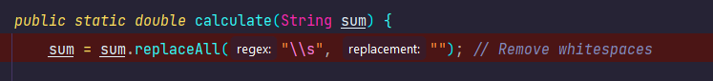  
2) Separate “sum” into Numbers and Operators and add it into a List

3) Loop for each of Character in “sum”. It will enter this condition if the current char “c” is a number. This code snippet then will combine number and point/decimal together by looping and check all the next number or decimal until it found operator then only it will break from the loop. Then, the combination will be added in to numbers List.

4) Then, it will continue to check next available char after the last number combination. The condition will if it’s operator by entering method isOperator and passing char c. If the operators already have the value in the List, then only it will compare the precedence. If the existing operator in the List has greater priority than the current operator, it will directly start the calculation in “evaluate” method and the result will be added in the numbers list. Else, it will just add the current operator into the operator list.

5) Next, if char “c” has bracket “(“. It will directly added

6) When step 5 is done, there is two possibilities, either another bracket is the next char or a number. If it’s number, then it will do logic on step 3 and if it’s operator, it will do logic on step 4. Then when the next char has close bracket “)”, it will check if the operators is not a open bracket “(”, then it will directly calculate in “evaluate” method the current numbers with the operators and the result will be added in the numbers list. Next it will remove the last operator in the operator list.

7) When there is no more next char in “sum”, it will break from the for loop. Next, it will check if the operator is empty. If not empty, then it will continue to loop and enter “evaluate” method for the calculation. In evaluate method, it will remove the top number in the numbers list and set as double b. Then, the remove the next available numbers in the list. For example, the value in number list is { 15.4,11.5} , b will be assign to 15.4 and a will be assigned to 11.5. Then, it will remove the top operator in operators list. Based on this variable, it will enter switch case and calculate the value. The value then will be format into 2 decimal places and added into the numbers list.  
  
  
Below is the list of example and output screenshot from the program.

